**Lab Practical #08:**

Study Packet capture and header analysis by Wireshark (TCP, UDP, IP).

**Practical Assignment #08:**

1. **Explain usage of Wireshark tool.**

Wireshark is a network protocol analyzer, or an application that captures packets from a network connection, such as from your computer to your home office or the internet. Packet is the name given to a discrete unit of data in a typical Ethernet network. Wireshark is the most often-used packet sniffer in the world.

1. **Packet capture and header analysis by Wireshark (TCP, UDP, IP).**

**TCP:**

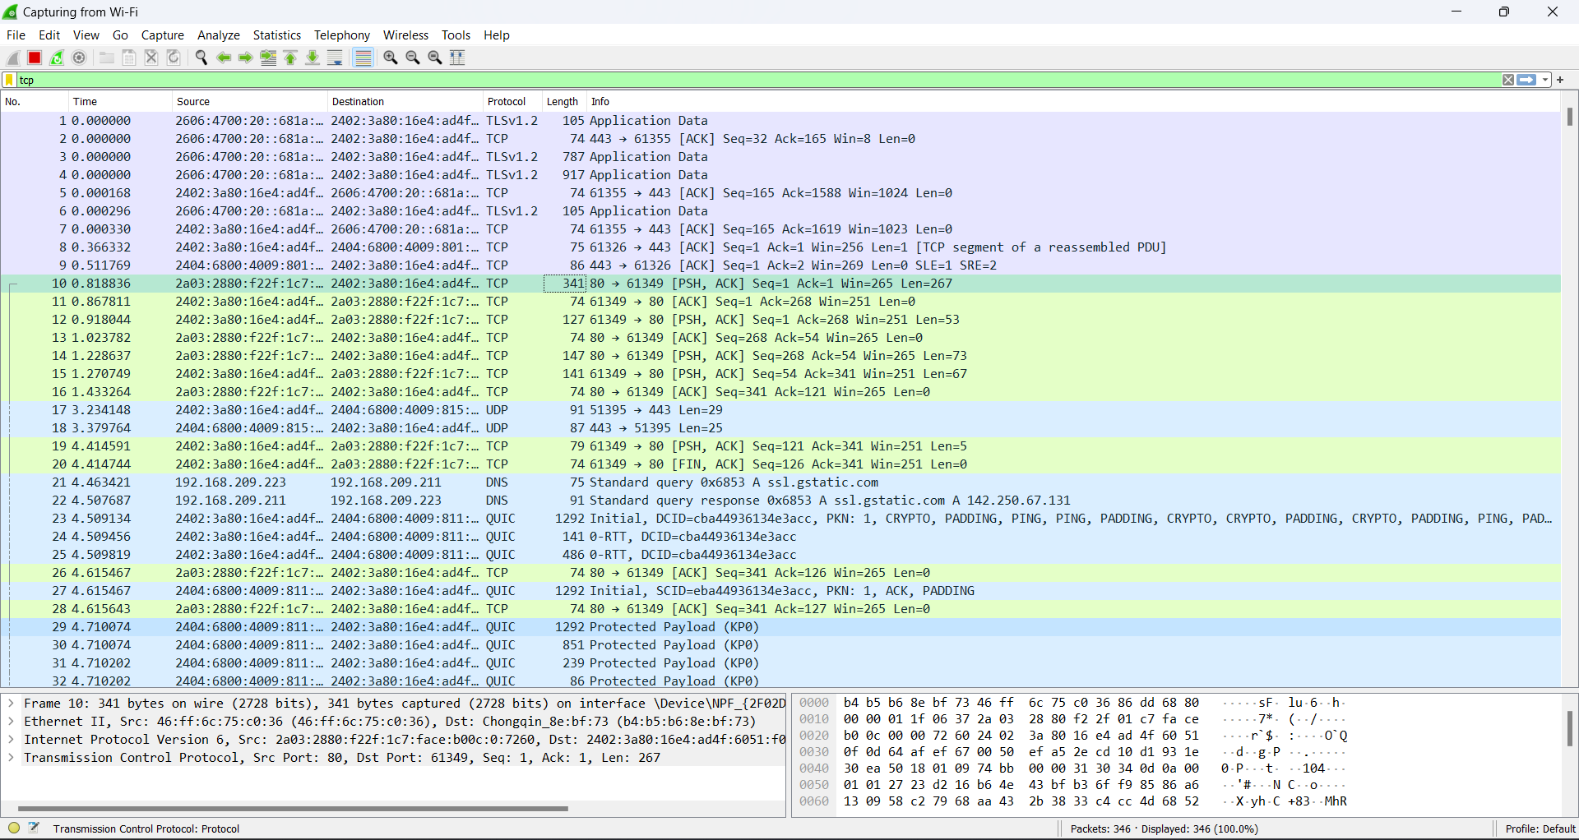

**UPD:**

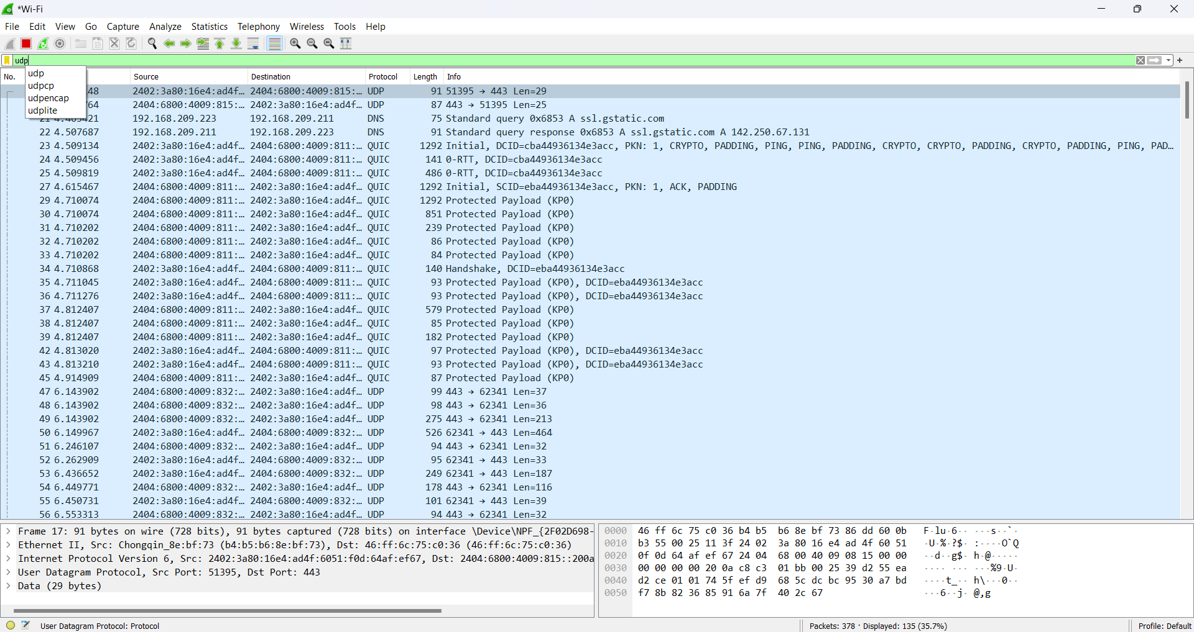

**IP:**

